**Name:- Dharan Gowda Superset id:-6387532**

**Create a react app for Student Management Portal named scorecalculatorapp and create a function component named “CalculateScore” which will accept Name, School, Total and goal in order to calculate the average score of a student and display the same.**

1)Create a React project named “scorecalculatorapp” type the following command in terminal of Visual studio:

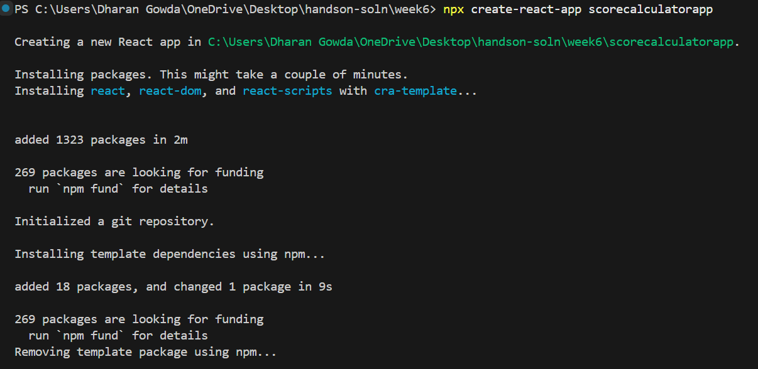

2)Create a new folder under Src folder with the name “Components”. Add a new file named “CalculateScore.js”

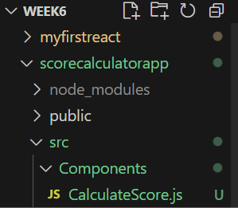

3)code in CalculateScore.js

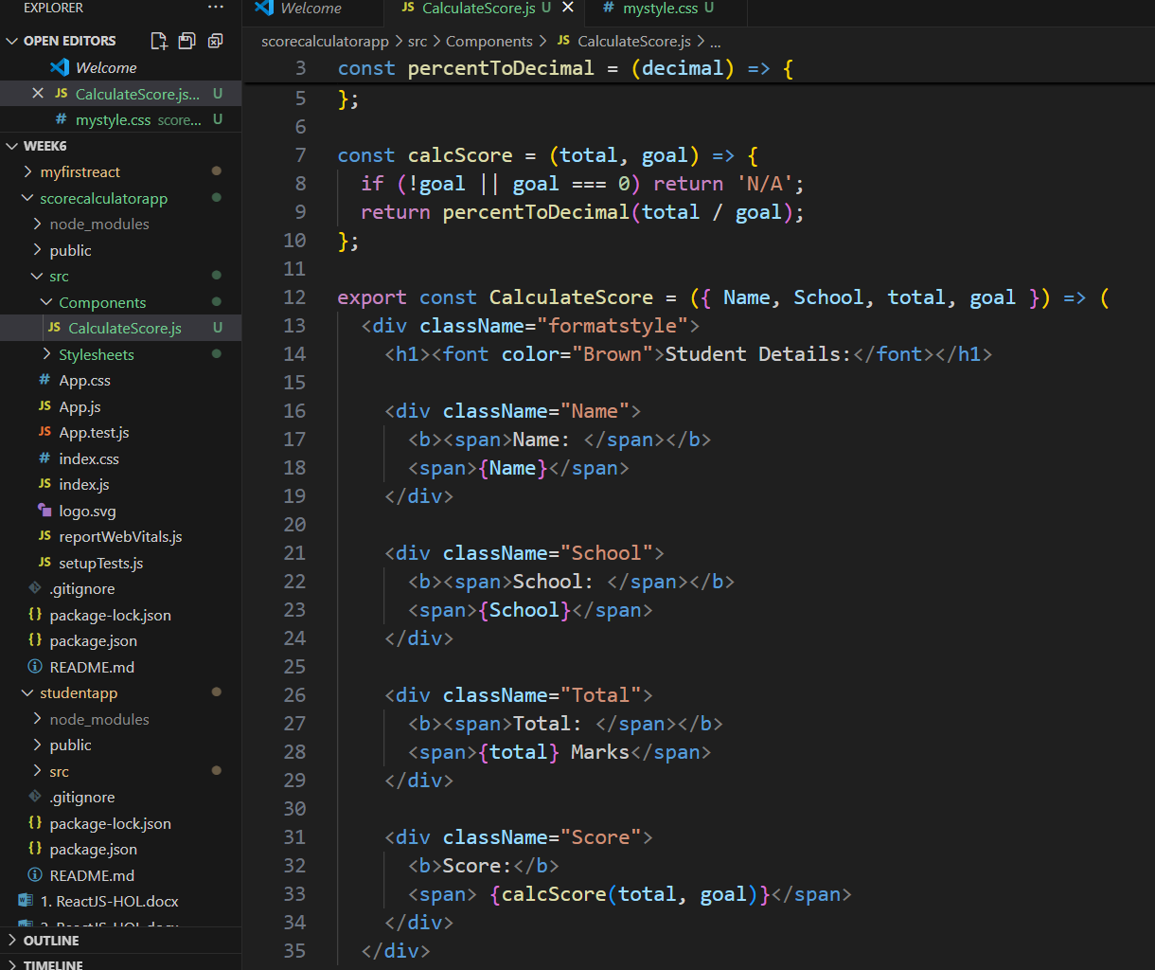

4)Create a Folder named Stylesheets and add a file named “mystyle.css” in order to add some styles to the components:

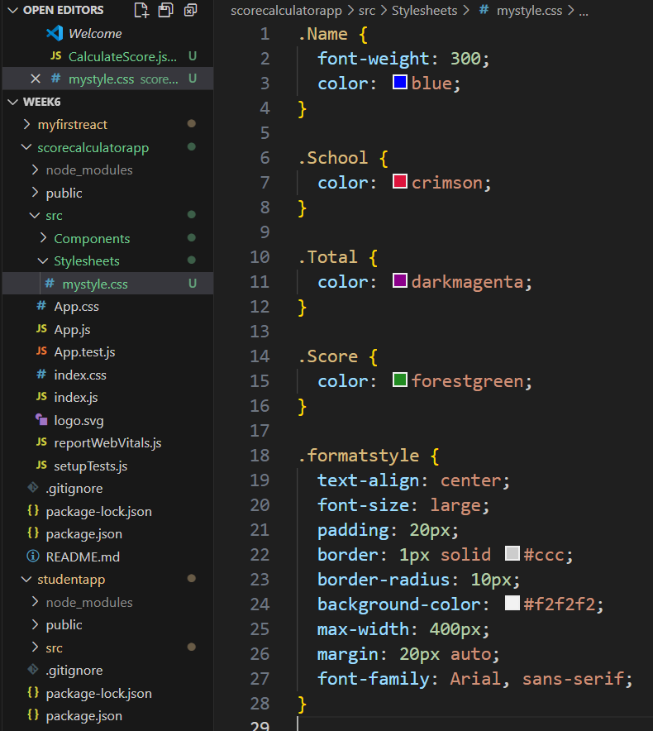

1. Edit the App.js to invoke the CalculateScore functional component as follows:

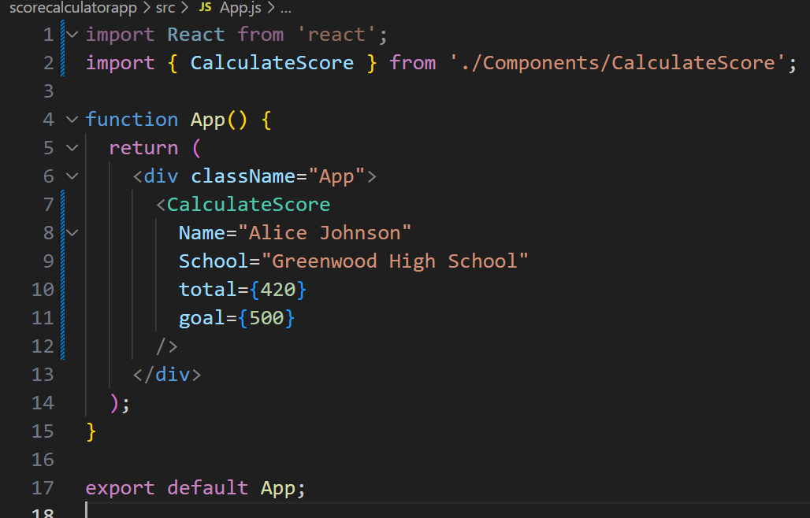

1. In command Prompt, navigate into scorecalculatorapp and execute the code by typing the following command:

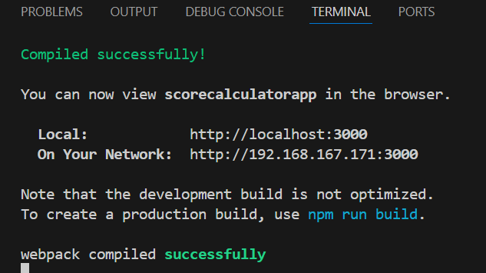

1. Open browser and type “localhost:3000” in the address bar

